A low cost real-time human activity recognition system based on the supervised learning algorithms

Nhung Tran Thi Hong^{1,*} Duc-Nghia Tran⁴, Van Thanh Pham^{2,3}, Duc-Tan Tran^{1, *}
¹ Faculty of Electrical and Electronic Engineering, Phenikaa University, Hanoi 12116, Vietnam
² University of Engineering and Technology, Vietnam University, Hanoi, Vietnam
³ The University of Fire Fighting and Prevention, Hanoi, Vietnam
⁴ Institute of Information Technology, Vietnamese Academy of Science and Technology, Hanoi, Vietnam
*Corresponding:
Email: nhung.tranthihong@phenikaa-uni.edu.vn (N.-T.T.H.); tan.tranduc@phenikaa-uni.edu.vn (D.-T.T.)
Tel.: +84-9-0418-2389 (D.-T.T.)

Abstract— Human activity recognition systems support the assessment of the health condition by providing their activity information. Machine learning algorithms offer high-performance recognition on acceleration data. Accelerometers are simple in setting up, and their price is low. Thus, human activity recognition system based on accelerometers is one of the leading solutions for monitoring health conditions. The major challenges in real context applications are the performance, the price, and the real-time requirement. An optimal time frame, a feature set, and a lightweight machine learning model are proposed in this manuscript to build a low-cost and responsive recognition system in real-time. A good recognition rate resulted in 99.2% on a recorded dataset for four daily activities (standing, sitting, running, and walking) with simple features set. The results were verified on both public data and our experiment data.
Keywords—recognition activity, classification, accelerometer, feature extraction

- INTRODUCTION
In the past several decades, the research on human activity recognition has enjoyed a strong development thanks to its application. More and more practical problems need solutions based on activity recognition such as healthcare [1], [2], fall detection for the elderly [3], [4], industry [5], security [6], etc. Activity recognition technology collects information user behavior, providing various ways to interact, thereby allowing the system to support users in their work [7] actively.
With the development of technology, sensors are becoming more and more diverse to improve the recognition rate and adapt to different situations. In the problem of human activity recognition, there are three common approaches: the computer vision-based approach, environment interactive sensor-based approach, and wearable sensor-based approach [8]. A camera or video is employed for a vision-based approach to observe user behavior and the surrounding environment changes [9]–[13]. However, in low light conditions, high cost, or affect user privacy, the usage of surveillance cameras has many limitations. With an environment interactive sensor-based approach, the sensor is embedded in the object or subject that constitutes the surrounding environment to monitor user activity [14], [15], [16], [17]. Like the computer vision-based approach, this system needs to be deployed and pre-install.
Different from the above approach, the wearable sensor-based approach using on-body sensors has opened up many potential applications in human activity recognition [18], [19], [20], [21]. They are suitable for the whole environment without setting up, whether indoor or outdoor. In this approach, the sensor can be worn in many different positions on the human body, such as arm, wrist [22], thigh [23], front pocket [24] hay ankle [25]. This study focuses on exploiting human state recognition using sensors carried on the body.
Several studies stood out when using multi-sensors to recognize human behavior. Bao et al. [23] collected data from five biaxial accelerometers and wore them on various positions such as hips, wrist, arms, ankles, and thighs on the group doing the research. Accuracy from the Decision Tree classifier for the results was 84%, with 20 activities classified. However, the limitation was the increased number of sensors, high speed, and accelerometer set to the specified orientation. Aiguo et al. [8] also compared the individual use of accelerometer and gyroscope sensors with the simultaneous use of both based on KNN and Naïve Bayes classifiers for recognition. Experimental results had shown that accelerometers provided more discriminatory information than gyroscopes and that the simultaneous use of both sensors type would give better classification performance. Naïve Bayes gave an overall accuracy of 90.1%, which is higher than KNN’s 87.8%. Multiple sensors could provide high accuracy but wearing the sensors interfered with human movement and is impractical to wear for long periods. In addition, the cost of the system would increase with the number of sensors.
Recently, many researchers are looking for activity recognition methods by using only one accelerometer to collect the signal [26]. For example, Piyush Gupta et al. [27] explored the benefits of a belt-worn 3-axis accelerometer to collect data to build an activity recognition and feature selection system. They used two classifiers Naïve Bayes, KNN and found that using feature selection with a wrapper-based approach gave better results than filter-based. The classification results showed > 95% accuracy for all six activities. But the limitation is that the number of subjects for data collection was only seven subjects, all of them are young people, aged only 22-28 years old. Like Piysh Guta, Khan et al. [28] used a single 3-axis accelerometer mounted on the chest in a specific direction to distinguish different activities in daily life. Overall accuracy result was up to 97.9%, with a classification of 15 behaviors. However, when testing was carried out at five different locations, the system accuracy decreased by only 47%.
To overcome the above limitations, this study focused on using a single 3-axis accelerometer integrated into the low-cost system to limit the ability to impede human movement. Besides, analyze data from many objects to determine whether data was distributed in clusters corresponding to different activities. Our work makes several contributions. The first main contribution proposed in this field is using and demonstrating a simple feature set that gives good classification performance. The second one is to provide a low-cost recognition system and real-time response.
The content of this paper is summarized as follows. Section 2 describes the classification model, details data processing, analysis our proposed features set, and gives performance measurements. Section 3 represents classification results, discusses and compares our proposed method with some other methods. The last section summarizes the achieved results and our future research work.

- METHODOLOGY
  - Activities Recognition Model
Some of the machine learning models classified based on the commonly learning style are supervised learning, unsupervised learning, semi-supervised learning, and maybe reinforcement learning. Supervised learning algorithm predicts outcome or label of new input from the mapping function that generates the known (input, outcome) pair. Conversely, unsupervised learning has only input data without outcome or label to predict. Semi-supervised learning is a technique with a large amount of data, but only a portion is labeled. And reinforcement learning model allows the system to decide the best subsequent behavior based on the current state to maximize performance. In this study, approach supervised learning would be deployed to gain higher accuracy. The overall approach included three phases in human activity recognition: data acquisition, features analysis, and recognition activities, as shown in Figure 1.
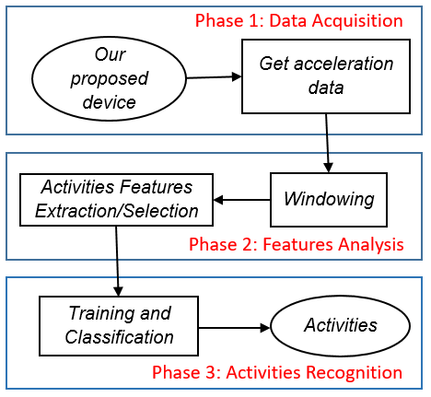
Figure 1. Block diagram of classification state process
In Phase 1, from our proposed device for classifying activities, we conducted to get acceleration data in three axes Ax, Ay, and Az. In Phase 2, we divided the data stream into small segments. Here, the sliding window was deployed to shift along the stream to capture all information about activities. Then, each vector generated from each of the above segments would contain features extracted from the data. The next step was to conduct feature selection to use as input of the classifier. And in the last phase, the features selected from the above step would be trained to build classification models. Based on the model learned, the classifiers were obtained to identify activities. Details of each task would be presented in the respective following sections.

  - Data Acquisition
To support for classifying activities, the proposed system integrated a sensor, a low-cost IMU, a wireless data transmitter/receiver to the wearing device. This device will transfer data to a smartphone with the Android operating system. This system can significantly decrease user inconvenience during recording data. Our proposed system structure is illustrated shown in Figure 2.
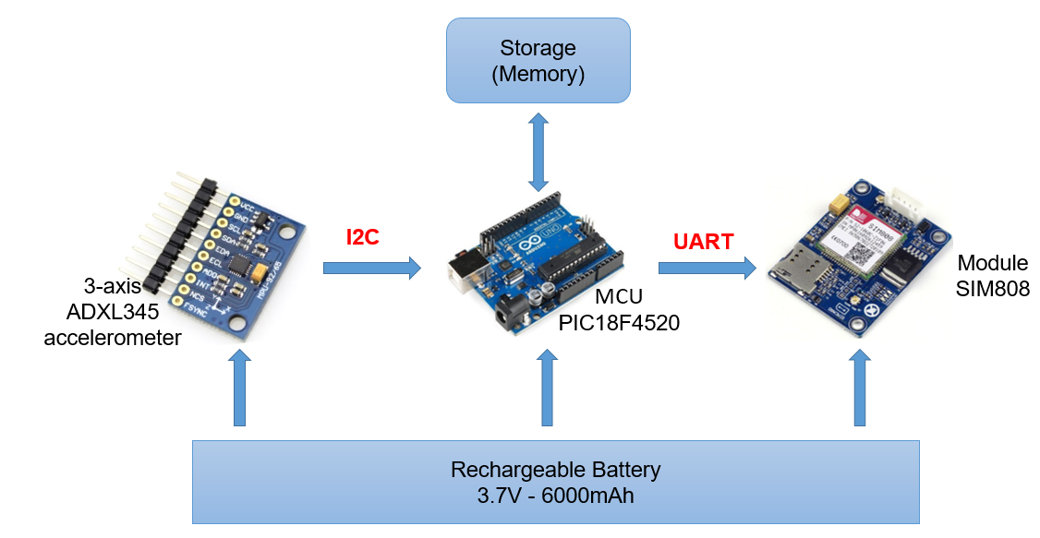
Figure 2. Block diagram of our proposed system
The accelerometer ADXL345 (3-DOF accelerometer) was connected to the MCU (PIC18F4520) by an I2C (inter-integrated circuit) interface to acquire data along three axes Ax, Ay, Az. In addition, Module SIM808 communicated with MCU via UART (Universal Asynchronous Receiver/Transmitter) communication. In this design, the device was powered by a rechargeable battery of 3.7V – 6000 mAh
Our experiment was deployed with laptop Dell E6540 was with a 2.7 GHz processor and 8G RAM. We conducted empirical data recording with a group of 14 students (seven males and seven females); ages: 18-22, height: 1.56-1.8 m, weight: 43-62 kg, who were selected from The University of Fire Fighting and Prevention (UFFP) and two older adults aged between 65 and 72, height: 1.4 m and 1.46 m, weight: 38 kg and 42 kg to obtain actual daily activities data. Our proposed device was held on the waist by the students with a sampling frequency of 50 Hz. It recorded four states: Standing for 43 minutes, Sitting for 32 minutes, Running for 10 minutes, and Walking for 22 minutes. Additionally, to test the algorithm's accuracy, we also used a public dataset [24]. This dataset was also collected daily activities from the accelerometer with the participation of thirty-six people. Detailed descriptions and some illustrations of activities are shown in Table 1 below.

Table 1. Description human activities
Activity | Description
Standing | Standing with subtle movements
Sitting | Sitting on a chair
Jogging | Jogging
Walking | Normal walking, stairs up and stairs down
After building the model as shown in Figure 1 and designing the system with hardware devices as shown in Figure 2, we applied the algorithm to this device. The microcontroller was the Central Processing Unit of the device that was an embedded device. Therefore, when performing real-time identification, there were memory requirements and algorithmic complexity. Consequently, the Decision Tree algorithm was suitable for deploying human activity recognition on wearable devices in real-time. The decision tree was based on the data after training to give the feature thresholds to form a binary decision tree. Based on that, we proceed to program the wearable device to recognize the real-time activity. Figure 3 below illustrates the proposed algorithm flowchart.
To continue to establish the connection between the sensor, MCU and SIM Module, we proceed with the following steps: First, we declared the ADXL variable from the ADXL345 library to set up the threshold values of activity or inactivity, tap detection on axes and set interrupt for step Set up. In the Loop step, we were deciding which activity was based on the Decision Tree algorithm. Every 6 seconds, the device would calculate, analyze and send back the activity results measured by the device to ensure real-time response and minimal complexity.

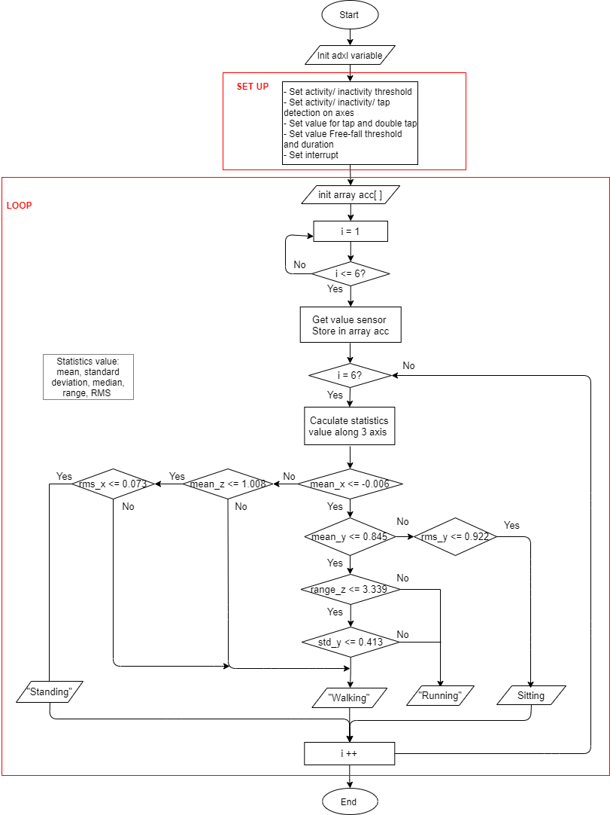
Figure 3. The flowchart for our device
  - Features Analysis
- Windowing
After collecting data from the sensor, the acceleration data would be used to analyze the features of activities. Firstly, we conducted to divide the data stream into small segments that can potentially contain action information. People performed activities smoothly, and activities that took place in succession affect each other. Besides, determining the exact boundary of activity was quite difficult, so segmentation of the data was essential.
There were many methods for segmentation, such as segmentation using a sliding window, energy-based segmentation, rest-position segmentation, the use of one sensor modality to segment data of a sensor of another modality, and external context sources [29]. In this paper, the sliding window approach was chosen to segment data because of its simple implementation and lack of preprocessing suitable for real-time application [30]. This approach was proven effective for recognizing periodic (e.g., walking, running) and static activities (e.g., standing, sitting). In this technique, the sensor signals are partitioned into fixed-size time windows. These can be of two types: non-overlapping (time windows do not intersect) and overlapping windows (the intersection of adjacent windows).
The selection of the window size significantly affects the recognition performance of the system. Consequently, it was necessary to experiment with different window sizes to choose the most optimal value. J.R. Kwapisz [24] segmented the data into a 10s window size without overlapping and demonstrated that the 20s window size gave less promising results. To select the best size, we conducted experiments with many different sizes (1s – 22s) with overlapping intervals [0%, 95%] and gave good results window with fixed length 10s with 50% overlapping. Choosing this window was if the window length selection is too short, the window wouldn’t provide enough information to describe activities. Conversely, if the window size was too large, it could accommodate the knowledge of various types of activity in a single time window. By choosing this length of the window, the effective measurements contained the entire process of all behavior to ensure the integrity of each activity.
First, we conducted public data analysis. The number of activity observations using 10s window size was shown in Table 2. The extracted dataset contains a total of 10482 observations with 50% overlapping.

Table 2. Composition of activity observations public data
Behavior pattern | Number of observations
Standing | 445
Sitting | 548
Jogging | 3258
Walking | 6231
Total | 10482

- Proposed Feature Extraction
To get high classification efficiency, the selection of features that inform the activities is extremely important. In this section, feature selection was performed before feature extraction. For feature selection, we analyze partial data of each activity. Partial of the data (200 first samples) obtained from the sensor in the X-axis was represented via Figure 5 to determine the sensor value ranges and characteristics corresponding to each activity.
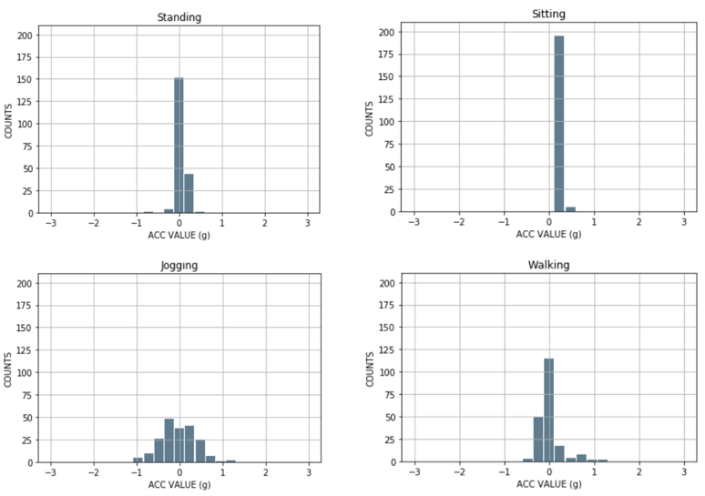
Figure 4. Histogram of a partial representation of data in X-axis
From Figure 5, we could see that the static state (Standing, Sitting) had values within a certain small range. For example, Standing had about 150 values concentrated at a_{x} ≈ 0g, Sitting had nearly 200 values along the X-axis centered at (0.12g, 0.36g). Therefore, we could easily use two features, mean and median, to measure the concentration of data to distinguish static states from dynamic states and classify static states from each other.
In addition, dynamic states such as Jogging, Walking had a wider range of values than static states. According to Figure 5, the X-axis sensor value of Jogging had a variation range (-1.08g, 1.32g), Walking ranged (-0.6g, 1.32g), while a range of Sitting was (0.12g, 0.6g). Consequently, the range was selected to determine the difference between these states' highest and lowest value.
Also, from Figure 5, between dynamic states, Walking data had the largest value density at x = (0.12g, 0.12g) and sparse on both sides. Meanwhile, Jogging had more even density of values than Walking. Therefore, standard deviation (SD) was a feature to determine the data spread of this activity when compared to the mean to capture the difference from another state.
As shown in Figure 5, Standing and Walking had more a_{x} ≈ 0g values than Sitting and Jogging, so it was possible to choose RMS (root mean square) to characterize these activities.
The five statistical features we analyzed above-included mean, standard deviation (SD), median, range, and RMS (root mean square). Acceleration data calculated according to these statistical features of the activities in X, Y and Z dimensions are indicated in Table 3-5.
Table 3. Acceleration data in X dimension (g)
 | Standing | Sitting | Jogging | Walking
Mean | -0.07 | 0.19 | 0.00 | 0.12
SD | 0.30 | 0.45 | 0.92 | 0.57
Median | -0.11 | 0.16 | 0.00 | 0.07
Range | 2.46 | 2.32 | 4.03 | 4.03
RMS | 0.31 | 0.49 | 0.92 | 0.58

Table 4. Acceleration data in Y dimension (g)
 | Standing | Sitting | Jogging | Walking
Mean | 0.93 | 0.22 | 0.58 | 0.88
SD | 0.11 | 0.32 | 0.94 | 0.50
Median | 0.97 | 0.26 | 0.49 | 0.89
Range | 2.05 | 2.83 | 4.04 | 4.04
RMS | 0.94 | 0.39 | 1.10 | 1.01

Table 5. Acceleration data in Z dimension (g)
 | Standing | Sitting | Jogging | Walking
Mean | 0.07 | 0.68 | -0.01 | 0.01
SD | 0.14 | 0.39 | 0.60 | 0.40
Median | 0.08 | 0.84 | -0.02 | -0.02
Range | 1.16 | 2.53 | 4.01 | 3.97
RMS | 0.15 | 0.79 | 0.60 | 0.40
In Table 3, mean distinguished Standing (-0.07) from Sitting (0.19) in static states according to X-axis. In Table 4, SD could characterize Jog (0.92) with Standing (0.11). Median feature distinguished Standing (-0.11) from other activities (> -0.05) or Sitting (0.84) with the others (< 0.1) (according Table 5). The range of acceleration distincted Standing (1.16) and Jogging (4.01) (according to Table 5). In Table 3, RMS helped distinguish Jogging (0.92) with Walking (0.58) (according Table 3) or Standing (0.15) with the other (> 0.3) (according Table 5).
The formulas of 5 features (mean, standard deviation, median, range and RMS) in Table 6 below were calculated on the X axis, the formulas on the Y-axis and Z-axis were the similar.
Table 6. Definition of features: consider a signal X
 | where:  $X_{j}$ is the record j;  N is the total of data samples (a window size);  $x_{i}$ is the sample i of record $X_{j}$;  $µ(X_{j})$ is mean of $X_{j}$;  $σ(X_{j})$ is standard deviation of $X_{j}$;  min is the minimum value of $X_{j}$;  max is the maximum value of $X_{j}$;  ${RMS}_{X_{j}}$ is root mean square of $X_{j}$.
  Features | Fomular
  Mean | $µ(X_{j})=\frac{1}{N}$ $\sum_{i=1}^{N}{x_{i}}$
  Standard  deviation | $σ(X_{j})$ = $\sqrt{\frac{1}{N} \sum_{i=1}^{k}{{{(x}_{i}-µ)}^{2}} }$
  Median | $median(X_{j})=\frac{x_{\left(\#\frac{N}{2}\right)}+ x_{\left(\#\frac{N}{2}+1\right)}}{2}$, $X_{j}$ was sorted
  Range | range($X_{j}$) = [$\min_{i=1}^{N}\{x_{i}\}$, $\max_{i=1}^{N}\{x_{i}\}$]
  RMS (root  mean square) | ${RMS}_{X_{j}}$ = $\sqrt{\frac{1}{N} \sum_{i=1}^{N}{{x_{i}}^{2}} }$

After deciding to use the above 6 features, we proceed to divide the data set into two parts: training set and test set in 60%:40% ratio. Then ploting this training dataset to build the model. To have a clearer view of the training dataset contribution, we used an algorithm to reduce the number of data dimensions for the purpose of simple observation. Compared to PCA (Principal Components Analysis) which is a dimensional reduction algorithm with only linear data, t-SNE (t-Distributed Stochastic Neighbor Embedding) helps visualize nonlinear data by mapping multidimensional data to two or more dimensions consistent with human observation. In this paper, we used t-SNE tool algorithm map each point in 3-dimensional space (x,y,z) into 2-dimensional space.
Without using the features, it was easy to see confusion between most of the activities (Figure 6-a). But in Figure 6-b, when conducting the experiment with all 5 statistical features mentioned above, the boundary between the activities became clearer. Using all the features always yeilded better classification results than just using the individual features. We could see Standing (orange area) and Sitting (blue area) were easily classified. Jogging (pink area) and Walking (green area) were well classified, howerver there was some overlapping.
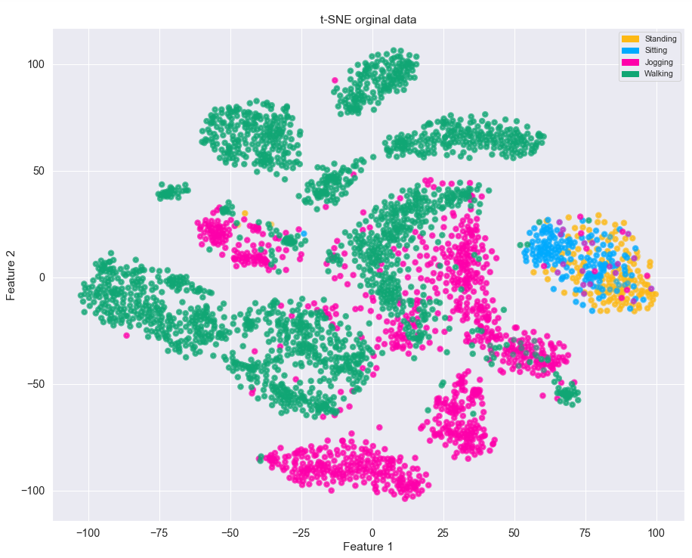  (a) | 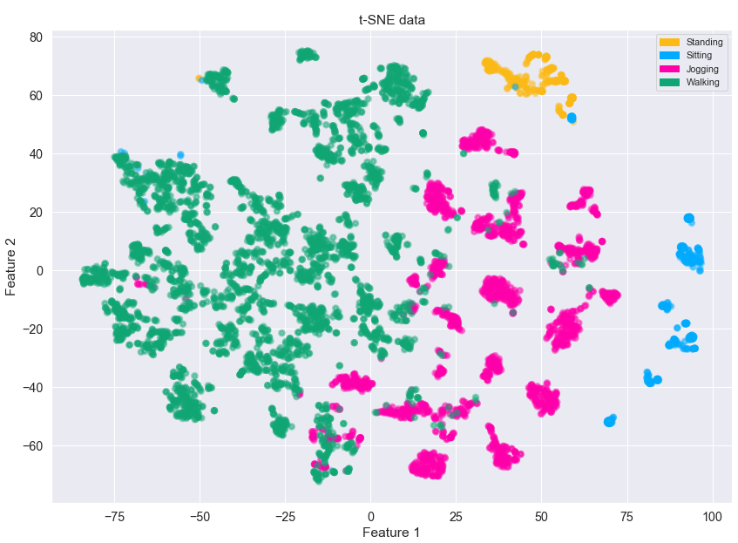  (b)
Figure 5. Representation public data in 2D space (a) without features (b) with features
Similar to public data, we also applied the above 5 features to our recorded data. Below is the number of activity observations using 10s window size (Table 7) và a representation of the training data using t-SNE algorithm. The extracted dataset contains a total of 1283 observations with 50% overlapping.
Table 7. Composition of activity observations our recorded data
Behavior pattern | Number of observations
Standing | 517
Sitting | 383
Running | 118
Walking | 265
Total | 1283

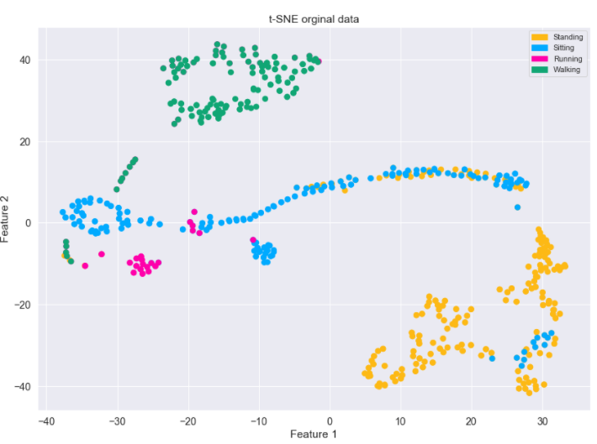  (a) | 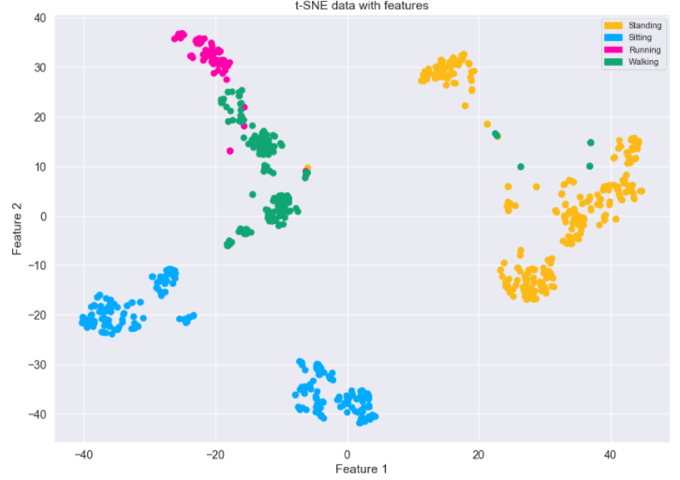 (b)
Figure 6. Representation our proposed data in 2D space
- without features (b) with features
In Figure 7-a, walking data (green area) và running data (pink area) had been classified quite well. But there was still a large confusion between standing (orange area) and sitting (blue area). After using five features, the overlap between standing and sitting was gone, the boundary between them was separated (Figure 7-b). However, there was a very small overlap between running and walking.
  - Recognition Activities
The classifier is the key to identify activities. Besides the high accuracy and short training time, classifiers often have to meet real time requirements. The feature set extracted in Section Features Analysis would be input to the training and classification process. Classification methods were widely used in machine learning and data analysis such as Gradient Boosted Decision Tree, Support Vector Machine, Random Forest, k-Nearest Neighbor through the available library Sklearn would be used to evaluate the performance of the classification model.
  - Estimation method
The performance of a classification model is often evaluated against a test dataset. There are different way to measure this performance, the most widely used is confusion matrix. The confusion matrix contains the actual ouput and the predicted output to estimate the classification performance. Accordingly, a few common measurements is deployed to build a better recognizerr such as overall accuracy, sensitity, PPV, NPV. The formulas for these measurements was shown below:
$$Accuracy= \frac{TP+TN}{TP + FP+FN+TN}$$ | (1)
$$Sensitivity= \frac{TP}{TP+ FN}$$ | (2)
$$PPV=\frac{TP}{TP+FP}$$ | (3)
NPV = $\frac{TN}{TN + FN}$ | (4)
In which, True positive (TP) is the case when an activity happens and the device predicts it to happen; true- negative (FP) is the case when an activity doesn’t happen but the device predicts it to happen; false-negative (FN) is the case when an activity happens but the device predicts different activity to happen; false-negative (TN) is the case when an activity doesn’t happen and the device also predicts that it doesn’t happen.
With the use of datasets with large difference in size between data classes (Walking data was relatively large compared to Standing - Table 2, two metrics, micro-average and macro-average, would be appropiate for the evaluation classification of the dataset.
Micro-average is defined according to the following formula with TP_{c}, FP_{c}, FN_{c} , TN_{c} being TP, FP, FN and TN of class C, respectively:
micro-average accuracy = $\frac{\sum_{c=1}^{C}{{(TP}_{c}+ {TN}_{c})}}{\sum_{c=1}^{C}{{(TP}_{c}+{FP}_{c}+{FN}_{c}+{TN}_{c})}}$ | (5)
micro-average sensitivity = $\frac{\sum_{c=1}^{C}{{TP}_{c}}}{\sum_{c=1}^{C}{{(TP}_{c}+{FN}_{c})}}$ | (6)
micro-average PPV = $\frac{\sum_{c=1}^{C}{{TP}_{c}}}{\sum_{c=1}^{C}{{(TP}_{c}+{FP}_{c})}}$ | (7)
micro-average NPV = $\frac{\sum_{c=1}^{C}{{TN}_{c}}}{\sum_{c=1}^{C}{{(TN}_{c}+{FN}_{c})}}$ | (8)
Macro-average is the average of the values of the classes:
macro-average accuracy = $\frac{1}{C}\sum_{c=1}^{C}{\frac{{TP}_{c}+ {TN}_{c}}{{TP}_{c}+{FP}_{c}+{FN}_{c}+{TN}_{c}}}$ | (9)
macro-average sensitivity =$\frac{1}{C}\sum_{c=1}^{C}{\frac{{TP}_{c}}{{TP}_{C}+{FN}_{c}}}$ | (10)
macro-average PPV = $\frac{1}{C}\sum_{c=1}^{C}{\frac{{TP}_{c}}{{TP}_{C}+{FP}_{c}}}$ | (11)
macro-average NPV = $\frac{1}{C}\sum_{c=1}^{C}{\frac{{TN}_{c}}{{TN}_{c}+{FN}_{c}}}$ | (12)

- RESULTS AND DISCUSSION
  - Experimental Results
We could easily compare the performance of each classifier such as Gradient Boosted Decision Tree, Support Vector Machine, Random Forest, k-Nearest Neighbor (KNN) based on their overall accuracy (Figure 7) and sensitivity (Figure 8) on public dataset with different window sizes (5s, 8s, 10s, 12s, 15s). On both measurements, Random Forest classifier gave the best classification performance: 95.3% accuracy and 94% sensitivity both 10s window size.
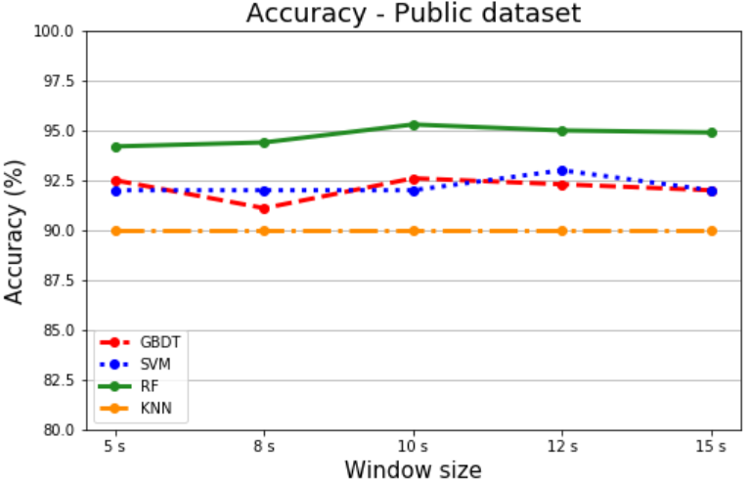  Figure 7. Accuracy of public dataset | 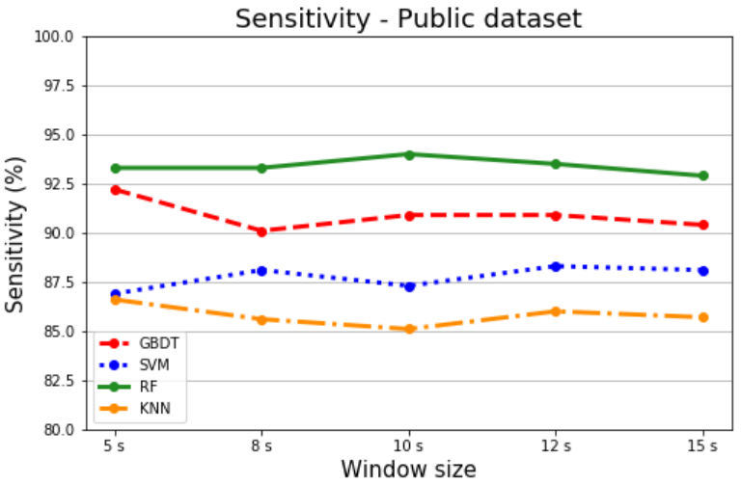  Figure 8. Sensitivity of public dataset
Similar to the public dataset, Figure 9 and Figure 10 represented the accuracy and sensitivity of our recorded dataset respectively with different window sizes and different classifiers. On both measurements, KNN classifier for highest accuracy (100%) and Random Forest (99.8%) classifier for highest sensitivity both 8s window size.
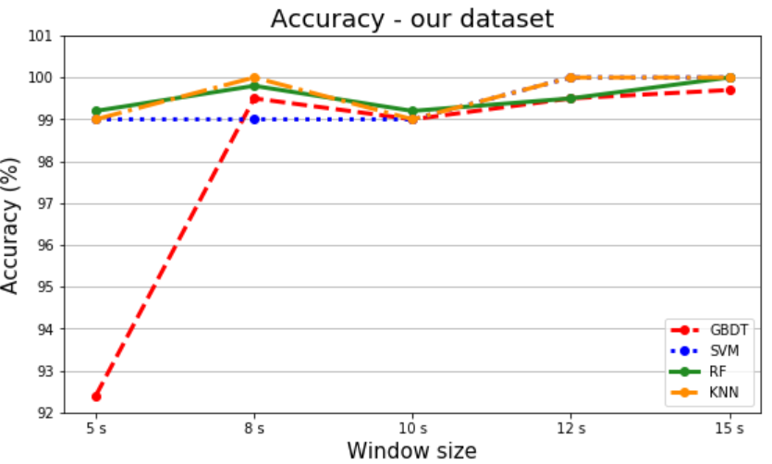  Figure 9. Accuracy of our dataset | 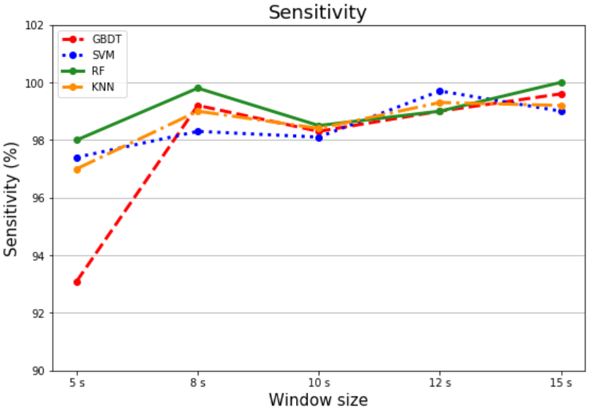  Figure 10. Sensitivity of our dataset
The detailed results for using Random Forest classifier were represented by the confusion matrix of public data (Table 8) and our recorded data (Table 9). From Table 8, most of the test samples of behaviors are relatively well differentiated (166/177 standing test samples, 208/218 sitting test samples, 1137/1302 jogging test samples, 2481/2491 walking test samples). But it could also be seen that there were 173 samples that are misclassified between jogging and walking. Between standing and sitting only 12 samples were misclassified.
Table 8. Confusion matrix of public data
Observed  behavior | Predicted behavior |  |  |  | Total
Observed  behavior | Standing | Sitting | Jogging | Walking | Total
Standing | 166 | 9 | 0 | 2 | 177
Sitting | 3 | 208 | 0 | 7 | 218
Jogging | 0 | 0 | 1137 | 165 | 1302
Walking | 0 | 2 | 8 | 2481 | 2491
Total | 169 | 219 | 1145 | 2655 | 4188
Table 9. Confusion matrix of our data
Observed  behavior | Predicted behavior |  |  |  | Total
Observed  behavior | Standing | Sitting | Jogging | Walking | Total
Standing | 206 | 0 | 0 | 0 | 206
Sitting | 0 | 151 | 1 | 0 | 152
Running | 0 | 0 | 44 | 2 | 46
Walking | 0 | 0 | 1 | 104 | 105
Total | 206 | 151 | 46 | 106 | 509
As with public dataset, in Table 9, most test samples of activities were very well differentiated (206/206 standing test samples, 151/152 sitting test samples, 44/46 running test samples, 104/105 walking test samples). Only 3 samples test were misclassifed between running and walking.
Performance indicators classify all activities (Section 2.5 - accuracy (1), sensitivity (2), PPV (3) and NPV (4)) represented in Table 10 và Table 11 on public and our dataset.
Table 10. Performance of model using indicators on public dataset
Behavior  pattern | Algorithm performance indicators
Behavior  pattern | Accuracy | Sensitivity | PPV | NPV
Standing | 99.7% | 93.8% | 98.2% | 99.7%
Sitting | 99.5% | 95.4% | 95% | 99.7%
Jogging | 95.9% | 87.3% | 99.3% | 94.6%
Walking | 95.6% | 99.6% | 93.4% | 99.3%

Table 11. Performance of model using indicators on our recorded dataset
Behavior  pattern | Algorithm performance indicators
Behavior  pattern | Accuracy | Sensitivity | PPV | NPV
Standing | 100% | 100% | 100% | 100%
Sitting | 99.8% | 99.3% | 100% | 99.7%
Jogging | 99.2% | 95.7% | 95.6% | 99.6%
Walking | 99.4% | 99% | 98.1% | 99.8%
Random Forest classifier gave relatively high classification result. Accuracy and NPV of all activities was excellent (> 95% on pulic dataset and > 99% on our dataset). Sensitivity and PPV had good value (> 93%) for all class except jogging (87.3%) on public dataset and > 95% on our data. In paricular, standing had an absolute indicator value, which was completely classified compared to the rest of the activities.
The overall performance of the dataset using two metrics (micro-average and macro-average – Section 2.5) were shown in Table 12 with the best performing classifier Random Forest. With micro-average estimation method, the results were relatively high (>95% on pulic dataset and > 99% on our dataset). As for macro-average evaluation based on independent calculation of each class and averaging, we got slightly lower results: > 94% on pulic dataset and > 98% on our dataset)
Table 12. The measurements to evaluate the performance of the RF classification model
Evaluation method | Micro-average |  | Macro-average
Evaluation method | Public data | Our recorded data | Public data | Our recorded data
Accuracy | 97.7% | 99.6% | 97.7% | 99.6%
Sensitivity | 95.3% | 99.2% | 94% | 98.5%
PPV | 95.3% | 99.2% | 96.5% | 98.4%
NPV | 98.4% | 99.7% | 98.3% | 99.8%

  - Discussion
In today’s modern life, health care needs are increasingly focused, especially for patients and the elderly. Advanced activity recognition applications are integrated to support human activities. Feature selection plays an important role in the recognition process. There were many studies that choose quite a lot of features to improve the rate of activitity identification such as 43 features [24], [31], [32]; 64 features [33]. The present study only used a simple and effective set of five statistical features and the best sliding window size for a relatively high recognition efficiency of 95.3% (public dataset) and 99.2% (our recorded dataset).
There is a difference in the results of the overall accuracy with two public and our recorded dataset (99.2% versus 95.3%) due to the larger number of participants in the public dataset (36 participants with 16 volunteers – our recorded data), resulted in more diversity in the sample data than the data we collected ourselves.
With the same WISDM public dataset, although the accuracy in [33] was higher with two classifiers (Ibk - 99.79% and J48 - 98.63%) but Vavoulas et al. used up to 64 features to achieve such accuracy, while our algorithm deployed few features (15 features) and gave an accuracy with Random Forest 95.3%.
In Reference [31], Catal et al. applied Voting algorithm by combining J48, Logistic Regression and Muli-Layer Perceptron, the result was 91.6%. Although they classified more activities (six activities) than our study, they tested a more complex algorithm when combining many different classification algorithms. Moreover, they used many features (43 features) and didn’t mention a low-cost design as we did.
Our algorithm could be applied to patients or the elderly but it couldn’t generalize to group of people doing particularly dangerous tasks such as firefighters. Because the activities of this subjects often took place with higher intensity in complex conditions such as large fires or dense smoke. Besides, an apparent limitation of the device was the need to fix the position of the sensor on the waist.

- CONCLUSION
In this study, we build a recognition system with low cost, small computation time and real-time response. The finding of this study confirms that a simple set of five features can help classify everyday behaviors relatively well, even though these behaviors are performed by different individuals. The test results when combining a 10s window size and classifier show that Random Forest classifier helps the algorithm achive a higher overall accuracy than Gradient Boosted Tree, SVM, KNN. For the further research, we further develop and confirm these initial finding by experiments on more complex activities to check the accuracy of the proposed model. Besides, in addition to the statistical features in the time domain, we can extend the extraction to other features such as features in the frequency domain or combining information in both time and frequency domains in feature extraction process. At the same time, experiments are able to conduct on maching learning models such as deep learning method to find the most optimal solution suitable for the goal of classification problem. Furthermore, we tend to develop and expand systems that automatically classify more complex behaviors, support and care for patients or the elderly more effective in specific circumstances.

ACKNOWLEDGEMENT

REFERENCES
[1] S. Chernbumroong, S. Cang, A. Atkins, and H. Yu, “Elderly activities recognition and classification for applications in assisted living,” Expert Systems with Applications, vol. 40, no. 5, pp. 1662–1674, 2013.
[2] K. K. B. Peetoom, M. A. S. Lexis, M. Joore, C. D. Dirksen, and L. P. De Witte, “Literature review on monitoring technologies and their outcomes in independently living elderly people,” Disability and Rehabilitation: Assistive Technology, vol. 10, no. 4, pp. 271–294, 2015.
[3] P. Pierleoni, A. Belli, L. Palma, M. Pellegrini, L. Pernini, and S. Valenti, “A High Reliability Wearable Device for Elderly Fall Detection,” IEEE Sensors Journal, vol. 15, no. 8, pp. 4544–4553, 2015.
[4] S. E.-R. Pham Van Thanh, Duc-Tan Tran, Dinh-Chinh Nguyen, Nguyen Duc Anh, Dang Nhu Dinh and K. Sandrasegaran, “Development of a Real-Time, Simple and High-Accuracy Fall Detection System for Elderly Using 3-DOF Accelerometers,” Arabian Journal for Science and Engineering, pp. 3–4, 2018.
[5] T. Stiefmeier, D. Roggen, G. Ogris, and P. Lukowicz, “Batra97.Pdf,” pp. 42–50, 2008.
[6] A. Jain and V. Kanhangad, “Exploring orientation and accelerometer sensor data for personal authentication in smartphones using touchscreen gestures,” Pattern Recognition Letters, vol. 68, pp. 351–360, 2015.
[7] N. N. Diep, C. Pham, and T. M. Phuong, “A classifier based approach to real-time fall detection using low-cost wearable sensors,” 2013 International Conference on Soft Computing and Pattern Recognition, SoCPaR 2013, pp. 105–110, 2013.
[8] A. Wang, G. Chen, J. Yang, S. Zhao, and C. Y. Chang, “A Comparative Study on Human Activity Recognition Using Inertial Sensors in a Smartphone,” IEEE Sensors Journal, vol. 16, no. 11, pp. 4566–4578, 2016.
[9] C. W. Lin and Z. H. Ling, “Automatic fall incident detection in compressed video for intelligent homecare,” Proceedings - International Conference on Computer Communications and Networks, ICCCN, pp. 1172–1177, 2007.
[10] F. Marquis-Faulkes, S. J. McKenna, A. F. Newell, and P. Gregor, “Gathering the requirements for a fall monitor using drama and video with older people,” Technology and Disability, vol. 17, no. 4, pp. 227–236, 2005.
[11] W. Y. Shieh and J. C. Huang, “Speedup the multi-camera video-surveillance system for elder falling detection,” Proceedings - 2009 International Conference on Embedded Software and Systems, ICESS 2009, pp. 350–355, 2009.
[12] L. Hazelhoff, J. Han, and P. H. N. De With, “Video-Based Fall Detection in the Home Using,” pp. 298–309, 2008.
[13] S. Torres, “Aging in Place: Fall Detection and Localization in a Distributed Smart Camera Network,” Critical Gerontology Comes of Age: Advances in Research and Theory for a New Century, pp. 151–163, 2018.
[14] M. Sundholm, J. Cheng, B. Zhou, A. Sethi, and P. Lukowicz, “Smart-mat: Recognizing and counting gym exercises with low-cost resistive pressure sensing matrix,” UbiComp 2014 - Proceedings of the 2014 ACM International Joint Conference on Pervasive and Ubiquitous Computing, pp. 373–382, 2014.
[15] T. Rahman et al., “DoppleSleep: A contactless unobtrusive sleep sensing system using short-range doppler radar,” UbiComp 2015 - Proceedings of the 2015 ACM International Joint Conference on Pervasive and Ubiquitous Computing, pp. 39–50, 2015.
[16] S. Jamil, A. Basalamah, A. Lbath, and M. Youssef, “Hybrid participatory sensing for analyzing group dynamics in the largest annual religious gathering,” UbiComp 2015 - Proceedings of the 2015 ACM International Joint Conference on Pervasive and Ubiquitous Computing, pp. 547–558, 2015.
[17] P. Hevesi, S. Wille, G. Pirkl, N. Wehn, and P. Lukowicz, “Monitoring household activities and user location with a cheap, unobtrusive thermal sensor array,” UbiComp 2014 - Proceedings of the 2014 ACM International Joint Conference on Pervasive and Ubiquitous Computing, pp. 141–145, 2014.
[18] C. Zhu and W. Sheng, “Wearable sensor-based hand gesture and daily activity recognition for robot-assisted living,” IEEE Transactions on Systems, Man, and Cybernetics Part A:Systems and Humans, vol. 41, no. 3, pp. 569–573, 2011.
[19] M. H. Lee, J. Kim, K. Kim, I. Lee, S. H. Jee, and S. K. Yoo, “Physical activity recognition using a single tri-axis accelerometer,” Proceedings of the world congress on engineering and …, vol. I, pp. 20–23, 2009.
[20] S. W. Lee and K. Mase, “Activity and location recognition using wearable sensors,” IEEE Pervasive Computing, vol. 1, no. 3, pp. 24–32, 2002.
[21] J. Pärkkä, M. Ermes, P. Korpipää, J. Mäntyjärvi, J. Peltola, and I. Korhonen, “Activity classification using realistic data from wearable sensors,” IEEE Transactions on Information Technology in Biomedicine, vol. 10, no. 1, pp. 119–128, 2006.
[22] Nishkam Ravi and Nikhil Dandekar and Preetham Mysore and Michael L.Littman, “Activity recognition from accelerometer data,” Lecture Notes in Networks and Systems, vol. 43, pp. 317–329, 2019.
[23] L. Bao and S. S. Intille, “Activity Recognition from User-Annotated Acceleration Data BT - UbiComp 2002: Ubiquitous Computing,” UbiComp 2002: Ubiquitous Computing, vol. 3001, no. Chapter 1, pp. 1–17, 2004.
[24] J. R. Kwapisz, G. M. Weiss, and S. A. Moore, “Activity recognition using cell phone accelerometers,” ACM SIGKDD Explorations Newsletter, vol. 12, no. 2, pp. 74–82, 2011.
[25] B. H. Dobkin, X. Xu, M. Batalin, S. Thomas, and W. Kaiser, “Reliability and validity of bilateral ankle accelerometer algorithms for activity recognition and walking speed after stroke,” Stroke, vol. 42, no. 8, pp. 2246–2250, 2011.
[26] W. Xiao and Y. Lu, “Daily Human Physical Activity Recognition Based on Kernel Discriminant Analysis and Extreme Learning Machine,” Mathematical Problems in Engineering, vol. 2015. 2015.
[27] P. Gupta and T. Dallas, “Feature selection and activity recognition system using a single triaxial accelerometer,” IEEE Transactions on Biomedical Engineering, vol. 61, no. 6, pp. 1780–1786, 2014.
[28] A. M. Khan, Y. K. Lee, S. Y. Lee, and T. S. Kim, “A triaxial accelerometer-based physical-activity recognition via augmented-signal features and a hierarchical recognizer,” IEEE Transactions on Information Technology in Biomedicine, vol. 14, no. 5, pp. 1166–1172, 2010.
[29] A. Bulling, U. Blanke, and B. Schiele, “A tutorial on human activity recognition using body-worn inertial sensors,” ACM Computing Surveys, vol. 46, no. 3, pp. 1–33, 2014.
[30] O. Banos, J. M. Galvez, M. Damas, H. Pomares, and I. Rojas, “Window size impact in human activity recognition,” Sensors (Switzerland), vol. 14, no. 4, pp. 6474–6499, 2014.
[31] C. Catal, S. Tufekci, E. Pirmit, and G. Kocabag, “On the use of ensemble of classifiers for accelerometer-based activity recognition,” Applied Soft Computing Journal, vol. 37, pp. 1018–1022, 2015.
[32] Y. Min, Y. Yin, and K. Khin, “Comparing the Performance of Machine Learning Algorithms for Human Activities Recognition using WISDM Dataset,” International Journal of Computer, vol. 4523, pp. 61–72, 2020.
[33] G. Vavoulas, C. Chatzaki, T. Malliotakis, M. Pediaditis, and M. Tsiknakis, “The MobiAct dataset: Recognition of activities of daily living using smartphones,” ICT4AWE 2016 - 2nd International Conference on Information and Communication Technologies for Ageing Well and e-Health, Proceedings, no. Ict4awe, pp. 143–151, 2016.

Microcontroller unit
Sklearn is the most popular and powerful machine learning library written in Python, provides many tools for processing supervised and unsupervised learning problems.

